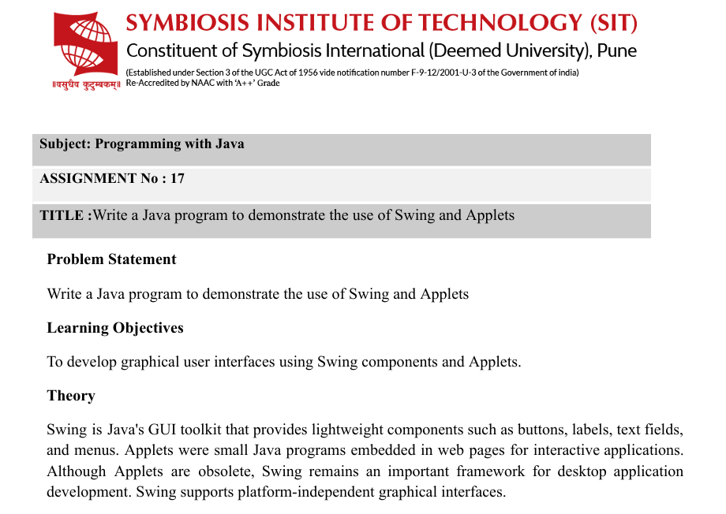
1.Theory
Swing is a part of Java used to develop Graphical User Interface (GUI) applications. It provides lightweight components such as JFrame, JLabel, JTextField, JButton, and JOptionPane.
- JFrame: Creates the main application window.
- JLabel: Displays text or information.
- JTextField: Accepts input from the user.
- JButton: Creates a clickable button.
- JOptionPane: Displays messages or information in a dialog box.
- ActionListener: Handles user actions such as button clicks.
Applets are small Java programs that were designed to run inside web pages. They were used to create interactive web applications. However, Applets are now obsolete and are not supported by modern browsers.
Swing is still used to develop desktop applications. It provides platform-independent GUI components and makes applications more interactive and user-friendly.
Detailed_Java_Lab_Manual(1)(1)(1).docx (3).pdf
2. Algorithm
- Start the program.
- Import the required Swing and AWT packages.
- Create a class that extends JFrame.
- Create labels and text fields to accept the required information.
- Create a Submit or Register button.
- Add all components to the frame using a suitable layout.
- Add an ActionListener to the button.
- When the button is clicked, retrieve the entered information using getText().
- Display the entered information using JOptionPane.showMessageDialog().
- Set the frame visible.
- Stop the program.

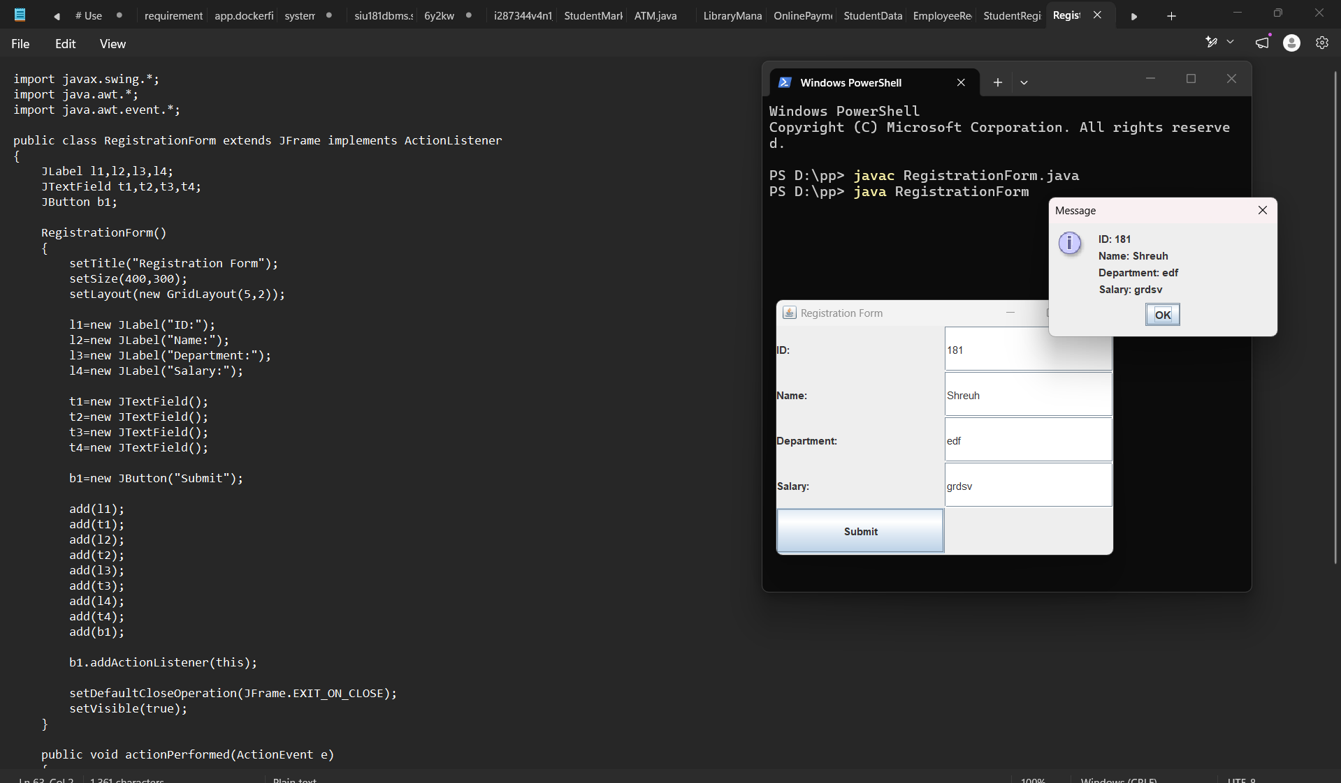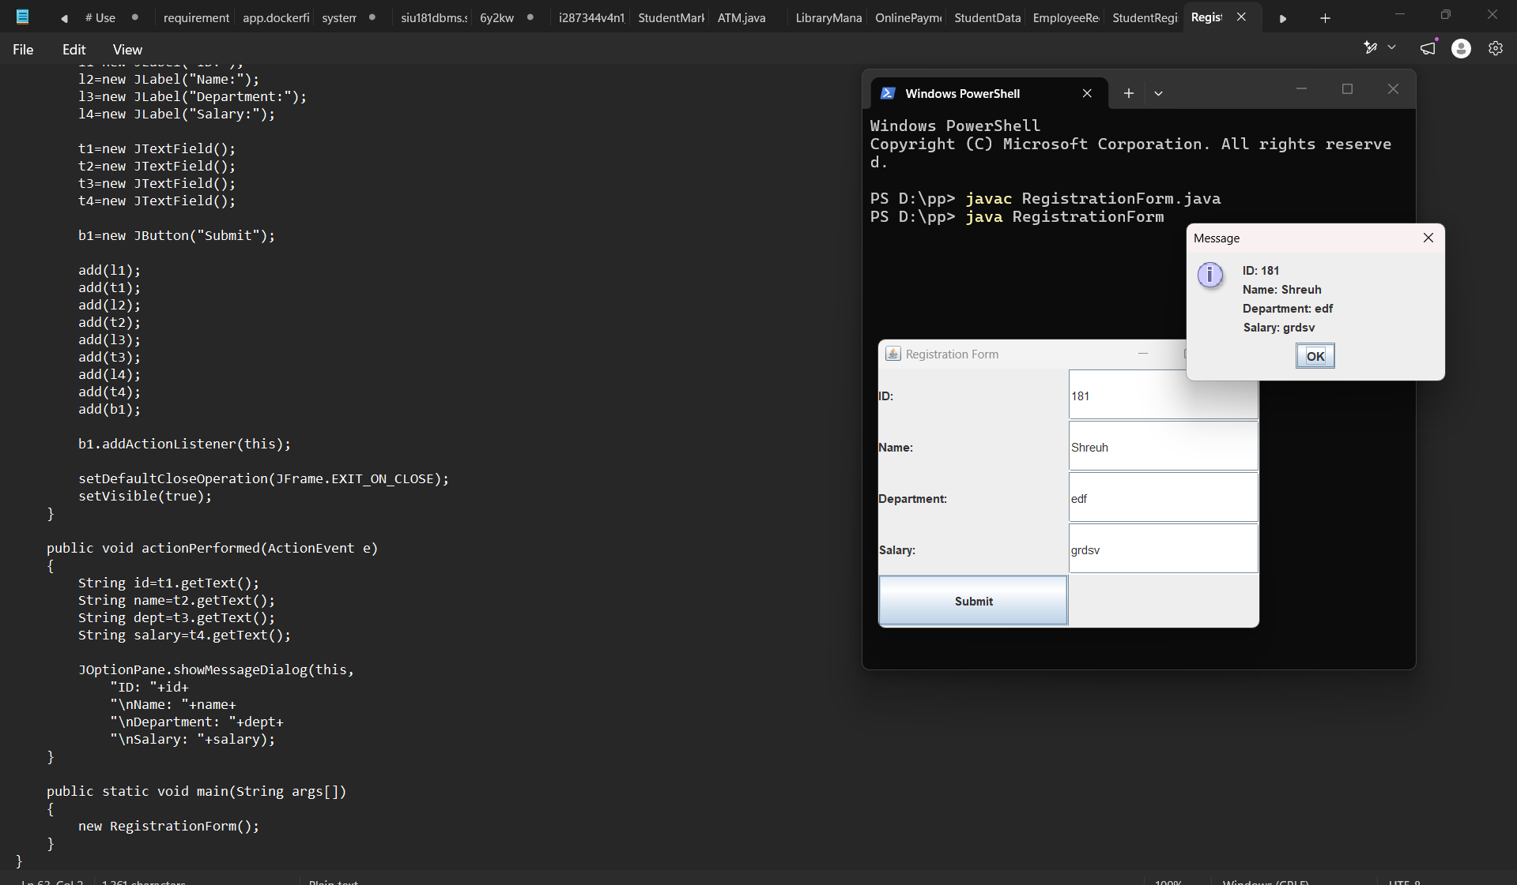
Exercise
- Create a simple Student Registration Form GUI using Swing.
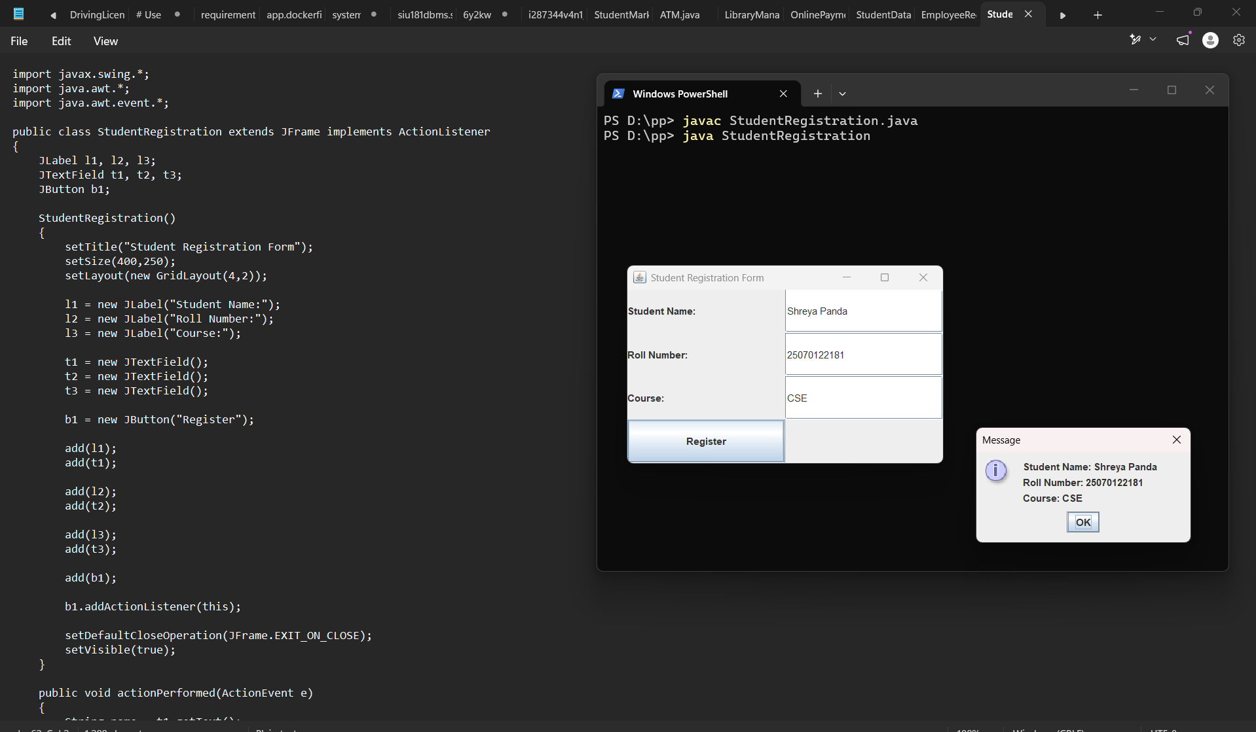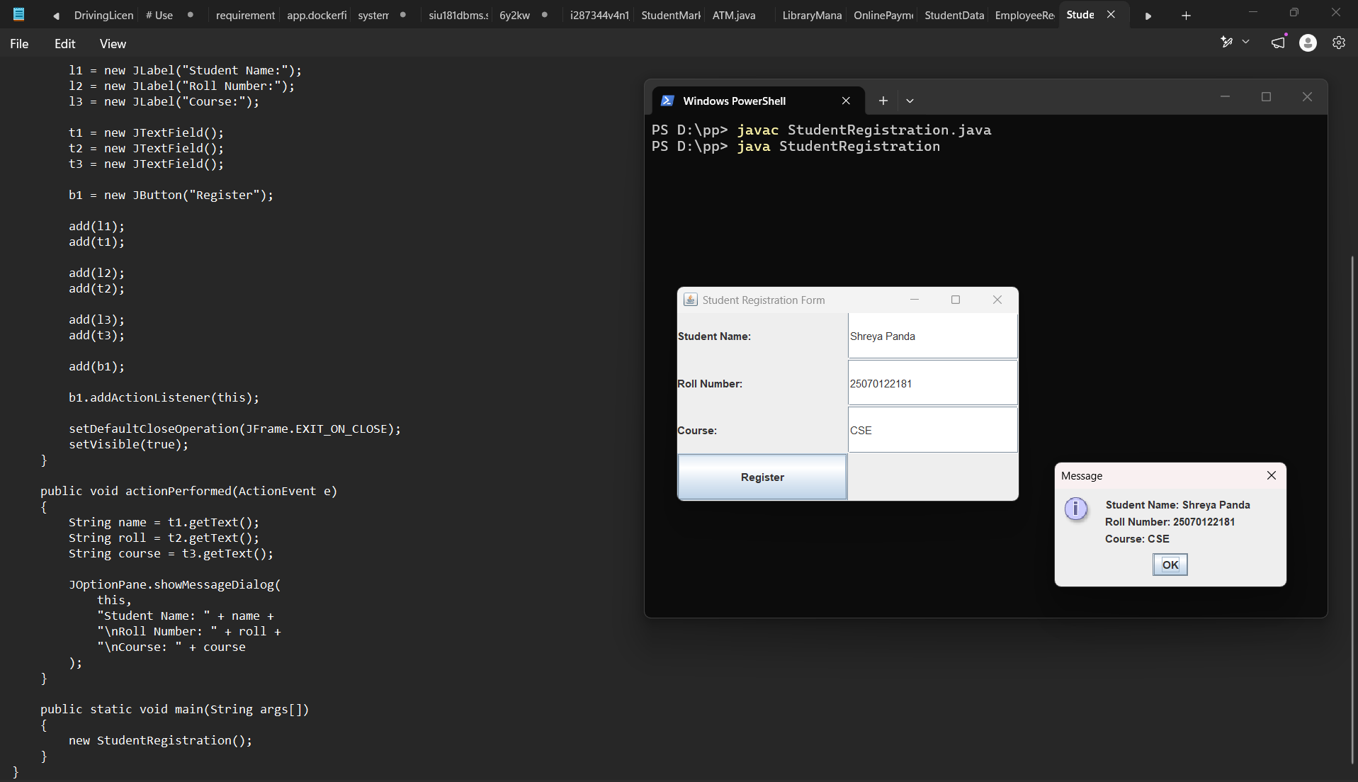

2. Create a simple Employee Registration Form using Java Swing GUI that takes employee details such as Employee ID, Name, Department, and Salary. Display the entered information in a dialog box
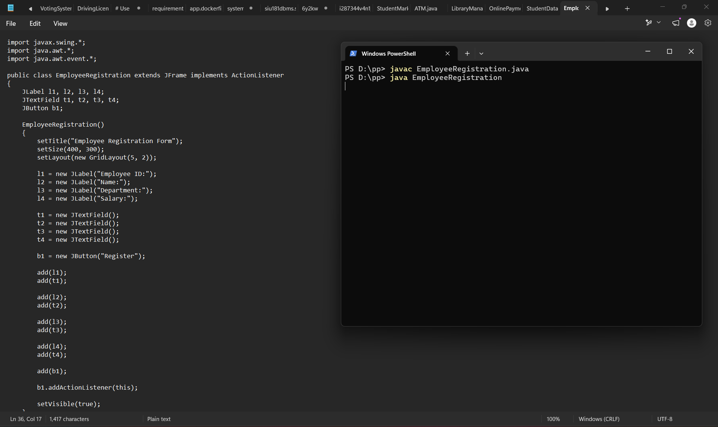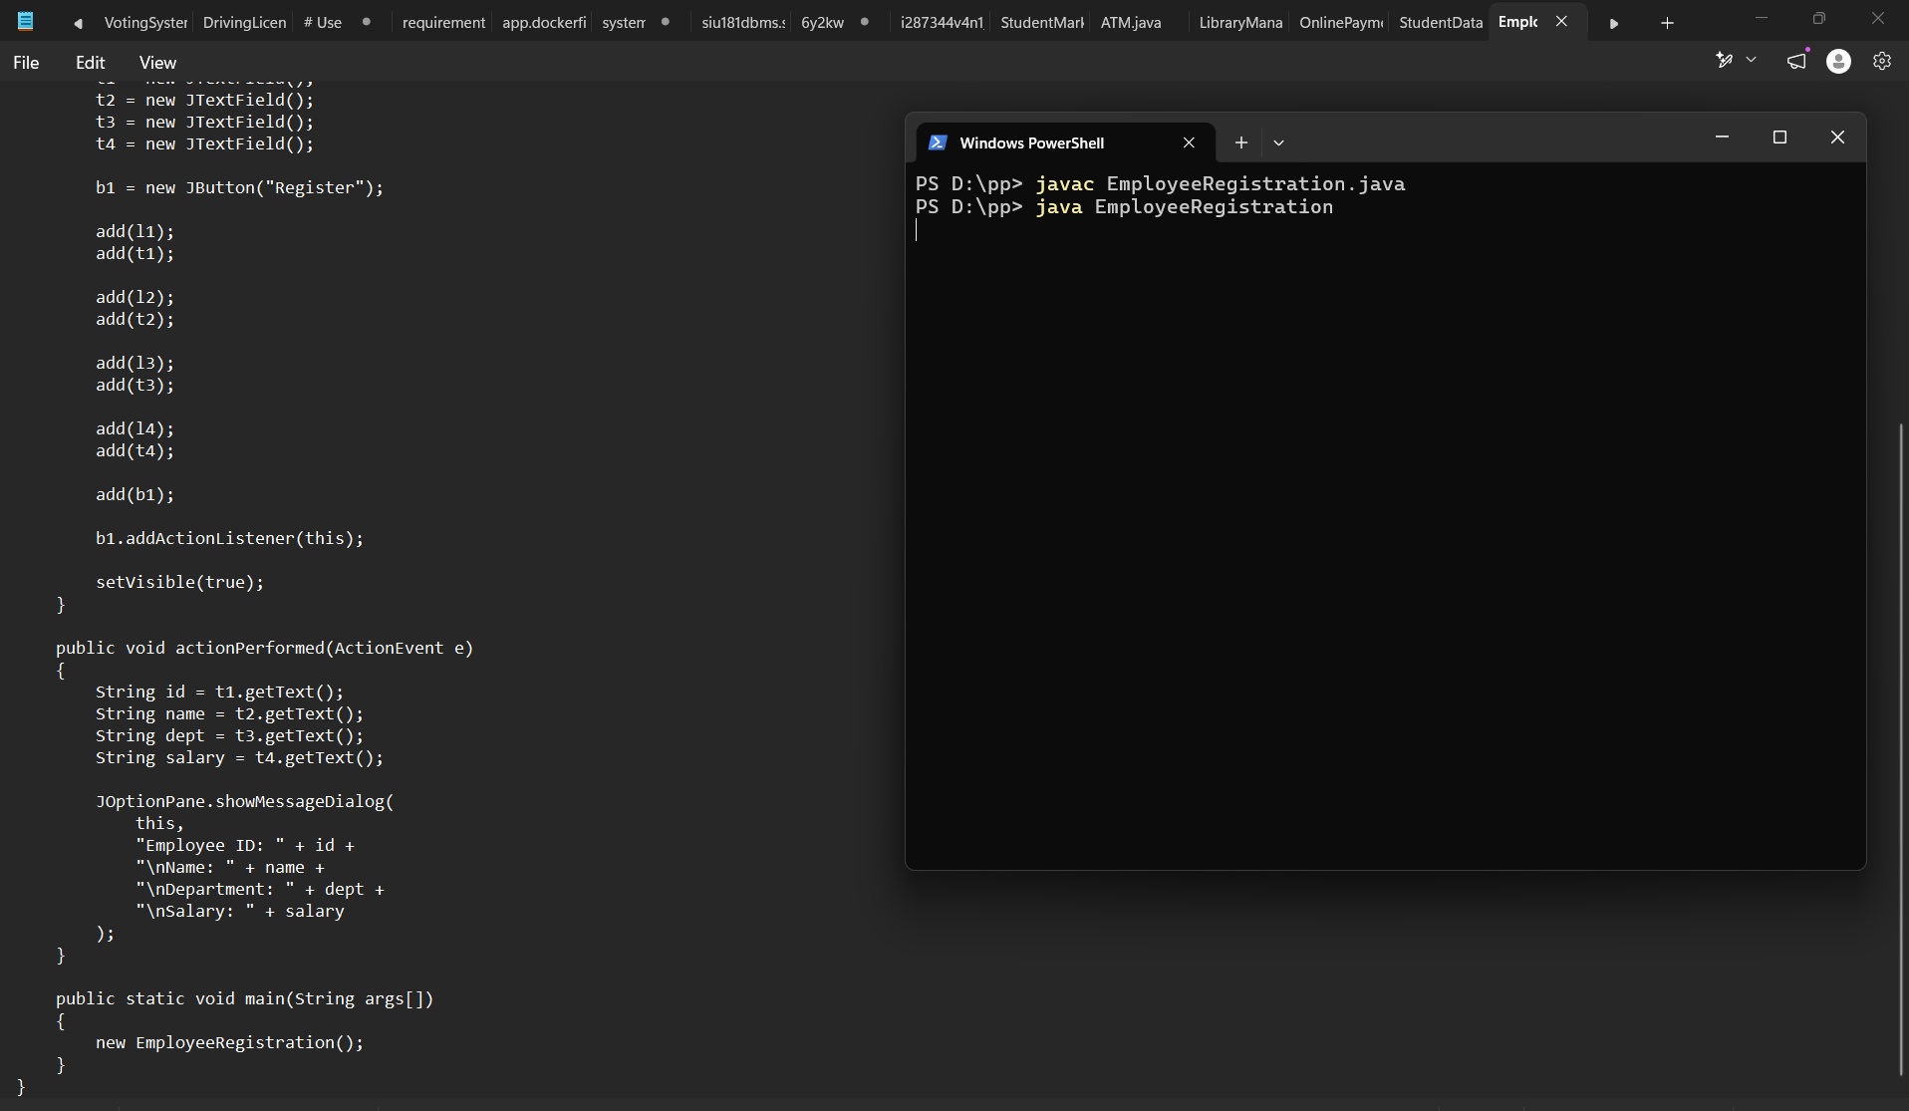
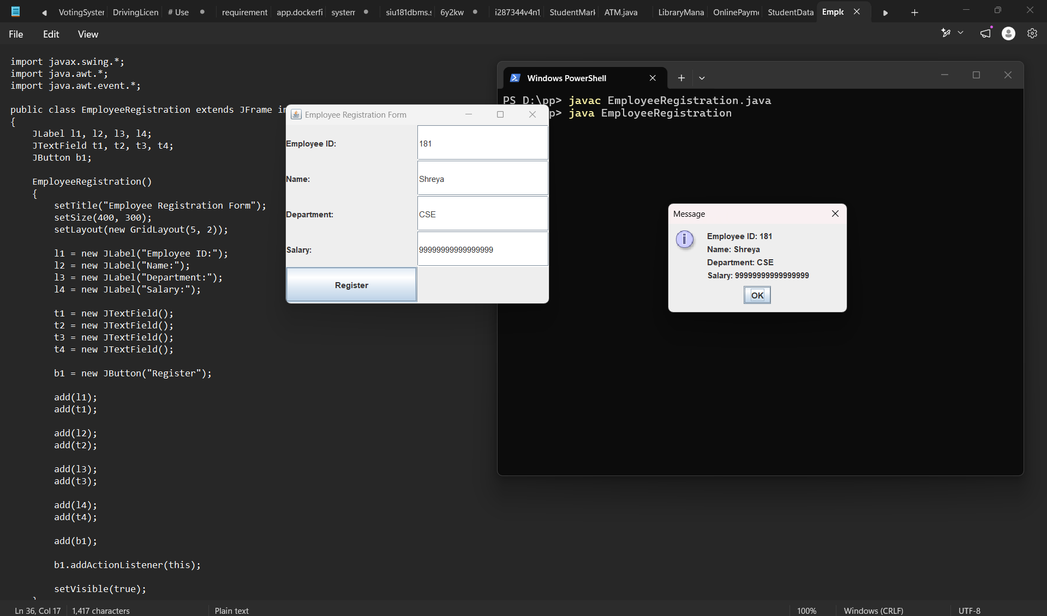
Conclusion
Thus, the program demonstrates the use of Java Swing components to create a Graphical User Interface (GUI). It accepts user information through text fields and displays the entered details using a dialog box. Hence, we learned how to create a user-friendly Java application using Swing components and handle button-click events.

